
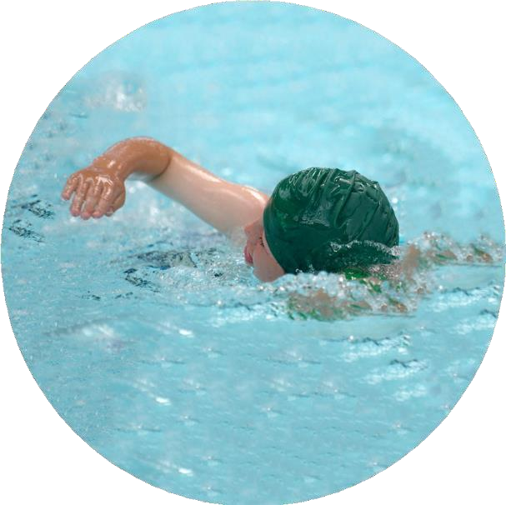
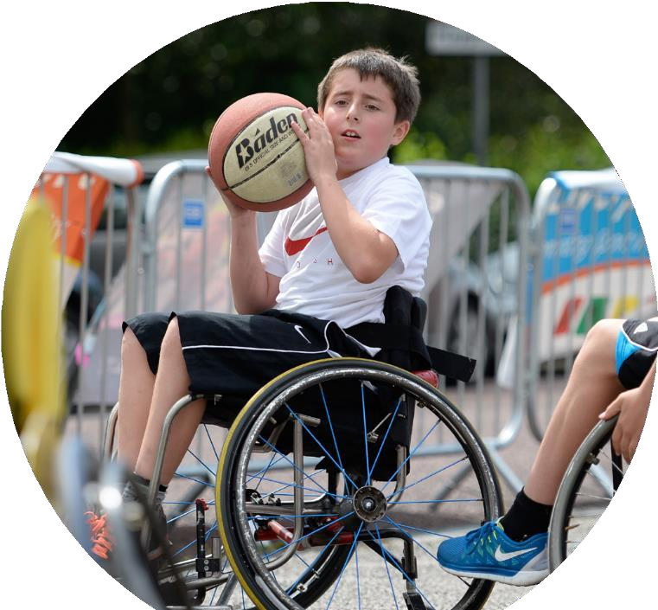
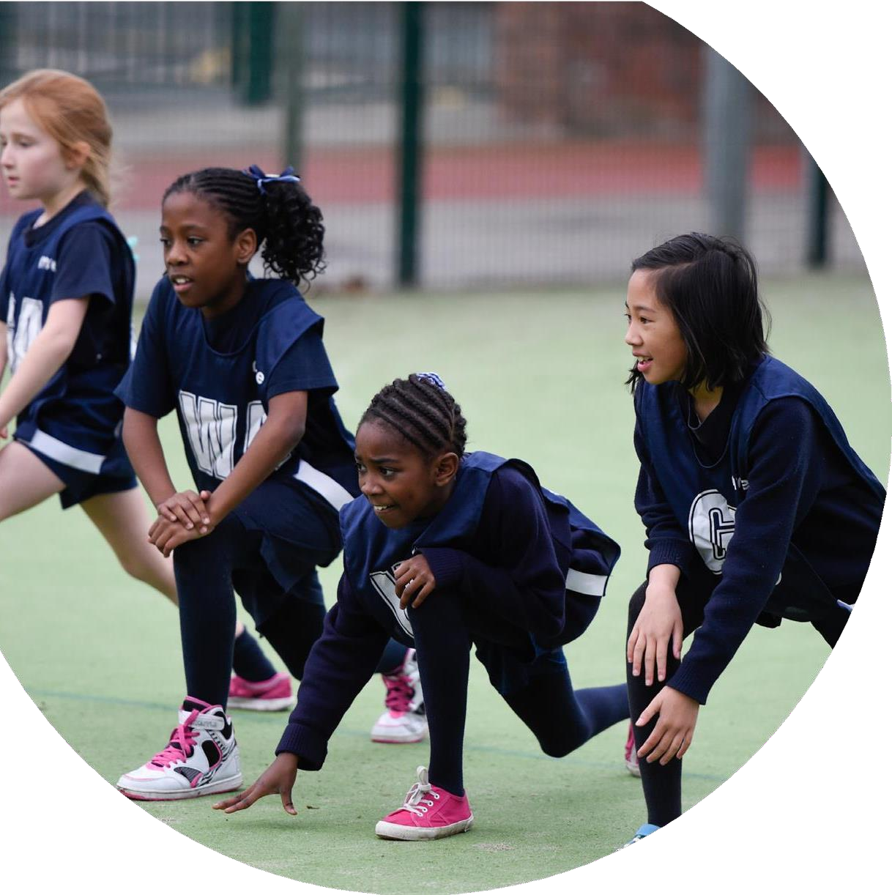


Evidencing the impact of the Primary PE and sport premium
Website Reporting Tool

Commissioned by the Department for Education Created by

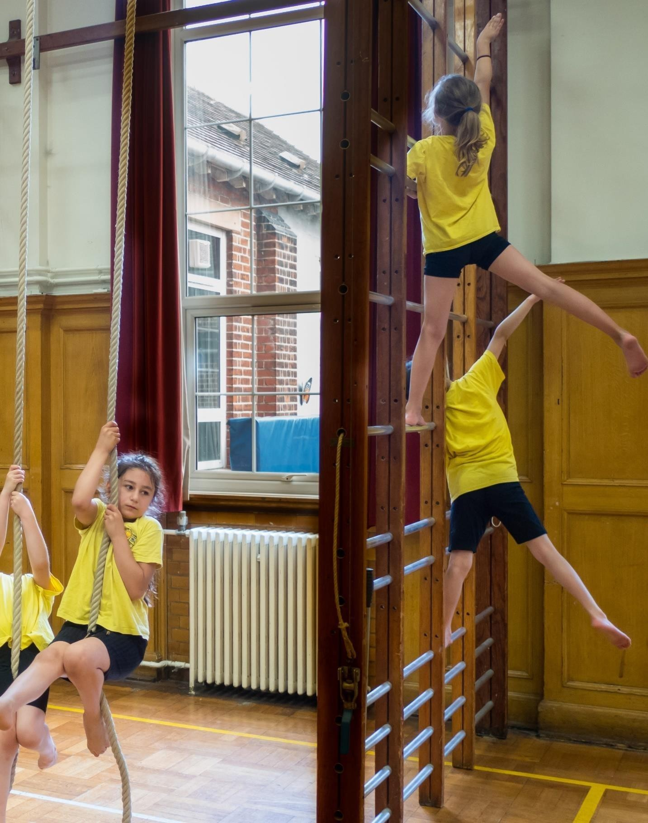



It is important that your grant is used effectively and based on school need. The Education Inspection Framework (Ofsted 2019 p64) makes clear there will be a focus on ‘whether leaders and those responsible for governors all understand their respective roles and perform these in a way that enhances the effectiveness of the school’.

Under the Quality of Education criteria (p41) inspectors consider the extent to which schools can articulate their curriculum (INTENT), construct their curriculum (IMPLEMENTATION) and demonstrate the outcomes which result (IMPACT).

To assist schools with common transferable language this template has been developed to utilise the same three headings which should make your plans easily transferable between working documents.

Schools must use the funding to make additional and sustainable improvements to the quality of Physical Education, School Sport and Physical Activity (PESSPA) they offer. This means that you should use the Primary PE and sport premium to:
- Develop or add to the PESSPA activities that your school already offer
- Build capacity and capability within the school to ensure that improvements made now will benefit pupils joining the school in future years
- The Primary PE and sport premium should not be used to fund capital spend projects; the school’s budget should fund these.

Please visit gov.uk for the revised DfE guidance including the 5 key indicators across which schools should demonstrate an improvement. This document will help you to review your provision and to report your spend. DfE encourages schools to use this template as an effective way of meeting the reporting requirements of the Primary PE and sport premium.
We recommend you start by reflecting on the impact of current provision and reviewing the previous spend.
Schools are required to publish details of how they spend this funding, including any under-spend from 2022/2023 as well as on the impact it has on pupils’ PE and sport participation and attainment by the end of the summer term or by 31st July 2024 at the latest.
We recommend regularly updating the table and publishing it on your website throughout the year. This evidences your ongoing self-evaluation of how you are using the funding to secure maximum, sustainable impact. Final copy must be posted on your website by the end of the academic year and no later than the 31st July 2022. To see an example of how to complete the table please click HERE.


Created by: Supported by:

Support for review and reflection - considering the 5 key indicators from DfE, what development needs are a priority for your setting and your pupils now and why? Use the space below to reflect on previous spend and key achievements and areas for development.

Please note: Although there has been considerable disruption in 2020 it is important that you publish details on your website of how you spend the funding - this is a legal requirement.
N.B. In this section you should refer to any adjustments you might have made due to Covid-19 and how these will influence further improvement.
Key achievements to date until July 2023: | Areas for further improvement and baseline evidence of need:
There has continued to be a legacy of lockdown this year particularly in the early part of the academic year which has affected progress to targets.  Staff and child absence has disrupted the continuity of flow and fewer out of school competitions meant less external opportunity. | To further improve, it is necessary to regularly monitor the items on the spending plan to ensure that they are consistently successful across all classes and build on the successes of this year.
Did you carry forward an underspend from 2022-2023 academic year into the current academic year? Yes

Total amount carried forward from 2022/2023 | £0
+ Total amount for this academic year 2023/2024 | £ 1 9 , 580
= Total to be spent by 31st July 2024. | £19,580

Meeting national curriculum requirements for swimming and water safety.
N.B Complete this section to your best ability. For example you might have practised safe self-rescue techniques on dry land which you can transfer to the pool when school swimming restarts.
Due to exceptional circumstances priority should be given to ensuring that pupils can perform safe self rescue even if they do not fully meet the first two requirements of the NC programme of study.
What percentage of your current Year 6 cohort swim competently, confidently and proficiently over a distance of at least 25 metres?  N.B. Even though your pupils may swim in another year please report on their attainment on leaving primary school at the end of the summer term 2021.  Please see note above. | 100%
What percentage of your current Year 6 cohort use a range of strokes effectively [for example, front crawl, backstroke and breaststroke]?  Please see note above. | 95%
What percentage of your current Year 6 cohort perform safe self-rescue in different water-based situations? | 95%
Schools can choose to use the Primary PE and sport premium to provide additional provision for swimming but this must be for activity over and above the national curriculum requirements. Have you used it in this way? | Yes

Action Plan and Budget Tracking
Capture your intended annual spend against the 5 key indicators. Clarify the success criteria and evidence of impact that you intend to measure to evaluate for pupils today and for the future.

Academic Year: 2023/2024 | Total fund allocated: £19.580 | Date Updated: 01.09.2023
Key indicator 1: The engagement of all pupils in regular physical activity – Chief Medical Officers guidelines recommend that primary school pupils undertake at least 30 minutes of physical activity a day in school |  |  |  | Percentage of total allocation:
 |  |  |  | 33%
Intent | Implementation |  | Impact
Your school focus should be clear | Make sure your actions to achieve | Funding | Evidence of impact: what do | Sustainability and suggested
what you want the pupils to know | are linked to your intentions: | allocated: | pupils now know and what | next steps:
and be able to do and about |  |  | can they now do? What has
what they need to learn and to consolidate through practice: |  |  | changed?:
Encourage active play at break and lunchtimes | Stowford already holds an OPAL Platinum Award but some of our best practice has been lost throughout lockdown. We will revisit and reinvigorate the award.  CPD for Meal Time Assistants Further work needs to be timetabled in for year 2023/2024.  Increase use of the new playground markings that were installed last year Train playleaders to use them with the younger children. | £300  £200  £36 | Play equipment ordered (goal posts, space hoppers, hoops, balls etc)  Sharon Kee trained MTAs to support/encourage play/games.  Year 6 Play leaders were trained to lead games and play activities during playtimes. | Continue to store equipment appropriately and audit throughout the year.  Ensure any new staff received training.  Adults to show children the correct use of play equipment.  Year 6s to train year 5s.
Provide targeted activities to encourage the less active children | Clubs: use Absolute Coaching to track which children are not taking part in clubs and target their  interests.  Use this information to identify  children and a special ‘invitation only’ club will be put on for these children where the agenda will vary week on week and will be decided by the children. | £295  £300 | Absolute Education used to track clubs and focus groups.  Forces club/ sunshine club for targeted PP children. | Continue to use Absolute Education as a register.  Continue this opportunity next year.

 | Continue to subsidise attendance at clubs and trips for disadvantaged children and add additional funding for active holiday clubs. This will be outsourced. | £1000 | All children were able to access clubs/trips. | Ensure this opportunity happens next year.
Encourage active lessons | Monitor the use of Teach Active and hold individualised CPD for teachers and teaching assistants to ensure that the core lessons of maths and English are more active and that this is consistent across all classes. | £2,500 | Children were more active and some teachers used the resource but due to time restraints and the current curriculum, this resource was not used to its full potential. | Teachers did not use Teach Active to its full potential therefore we will not use it next year.
Extend the range of clubs on offer | Continue to buy in some clubs that teachers cannot run themselves | No cost | PAFC  We do Football  District Sports –multi sports | Very successful.  Next year costing parents will continue to pay.
Raise attainment in swimming and rescue techniques | Catch up lessons for Y6 | £480 | Cost of hire of the leisure centre and staffing for the catch up lessons. | Dependent on numbers.
Target children with physical needs for focused gross motor skill intervention | Run Fun Fit sessions for invited children when a new member of  staff has been trained to carry this out. | £540 | Action and adventure club for selected children. | This was successful but due to staff changes, we will need to look at it for next year.
Involve whole school community for maximum commitment | Elect Sports Ambassadors to represent the children’s voice and build on last year’s experience. | Badges and meeting time  £100 | Sport Council- met fortnightly.  Support at Sports Day and multi skills events. | Parliament now introduced. Now a sports minister.
Celebrate physical achievement and effort regularly | Weekly PE cup for KS1 and KS2 in assembly awarded to one class.  Celebrated through social media and newsletters. | Minimal cost  £50 | Weekly PE Cup.  Social Media and newsletters updated with sporting celebrations. | To continue next year.
High profile of sportsmanship qualities | The school values of: respect, excellence, friendship, | Minimal cost | Celebration certificates.  PE has a high value. | To continue.

 | determination, inspiration, courage and equality are part of daily Stowford life.  Continue to celebrate weekly with certificates being awarded to individuals for demonstrating the values. |  | School values are discussed daily and during assemblies.
Key indicator 2: The profile of PESSPA being raised across the school as a tool for whole school improvement |  |  |  | Percentage of total allocation:
 |  |  |  | 14%
Intent | Implementation |  | Impact
Your school focus should be clear what you want the pupils to know and be able to do and about  what they need to learn and to consolidate through practice: | Make sure your actions to achieve are linked to your intentions: | Funding allocated: | Evidence of impact: what do pupils now know and what can they now do? What has changed?: | Sustainability and suggested next steps:
Active lessons to promote physical attributes, improved attitudes, motivation and well being | Teach Active as above | As above | See first section | Teachers did not use Teach Active to its full potential therefore we will not use it next year.
Pupils take on leadership roles and are positive role models for younger children | Y6 playleaders will work towards leadership awards  Children across the whole school will work towards the ‘Wild Tribe Award’ as a way of raising cultural capital for all children. | £200  £500 | Play leaders chosen and took on roles during lunchtime.  Wild Tribe days continued termly. | To continue next year.
Promote active travel to and from school | Bikeability training for Y5 children.  Build a scooter park for the increasing number of scooters that are being ridden to school. | £50  £900 | Bikeability took place in May 2024. | Very successful and to continue next year.

Apply for Gold Sports award | Stowford has achieved gold standard for several years and now would like to renew it. | No cost | Gold award achieved. | Ensure we apply next year.
For children and staff to take pride in PE and competitions. | Order team kits and staff kit with Stowford logo. | £1,200 | All kit ordered and replaced if needed. New staff provided with kit.  Kit issued for sporting events. | Audit kit and ensure all staff have the correct kit.

Key indicator 3: Increased confidence, knowledge and skills of all staff in teaching PE and sport |  |  |  | Percentage of total allocation:
 |  |  |  | 35%
Intent | Implementation |  | Impact
Your school focus should be clear | Make sure your actions to | Funding | Evidence of impact: what do | Sustainability and suggested
what you want the pupils to know | achieve are linked to your | allocated: | pupils now know and what | next steps:
and be able to do and about | intentions: |  | can they now do? What has
what they need to learn and to |  |  | changed?:
consolidate through practice:
Raise the standard of teaching and learning in PE lessons | Real PE CPD for all staff and resources needs to be monitored and coaching for success to be put in place.  Release PE leader to work alongside teachers for coaching | £560  £720 | RealPE CPD ran by Sharon.  Monitored lessons.  Pupil Voice  Sport Council | Ongoing.
Ensure all staff have the knowledge and resources to make lessons active | Teach Active CPD for all staff | Supply costs | See section 1 | Not continued. See above.

Ensure all staff have access to high quality resources and equipment to teach PE  Raise quality of teaching by working alongside coaches.  For PE leader to attend a ‘deep dive in PE’ webinar  PE leader to complete the Accredited PE Subject Leader award to enhance practice at the school (level 6) | Invest in appropriate resources and equipment.  Hire specialist coaches to come into school to work with staff.  - Enhance leadership of teaching and learning  - Set targets for improvement in PE  - Lead sustainable improvement  - Develop subject knowledge | £4,676  £1,000  £220  £575 | Resources were audited and replaced when needed.  Football coaches came into year 3  Attended course at China Fleet  PE leader successfully achieved award. | To continue next year.  Attend next year.  PE leader now trained and can support other teachers.
Key indicator 4: Broader experience of a range of sports and activities offered to all pupils |  |  |  | Percentage of total allocation:
 |  |  |  | 11%
Intent | Implementation |  | Impact
Your school focus should be clear | Make sure your actions to | Funding | Evidence of impact: what do | Sustainability and suggested
what you want the pupils to know | achieve are linked to your | allocated: | pupils now know and what | next steps:
and be able to do and about | intentions: |  | can they now do? What has
what they need to learn and to |  |  | changed?:
consolidate through practice:
Introduce a wider range of sports activities in the 3-6pm window | Continue to hire coaches from an external provider for clubs that we cannot provide ourselves | £600 | We do football  District sports  Netball  Athletics  Field Gun  Girls Football  Rugby  Junior Ten Tors  Dance  Gymnastics  Performing Arts | To continue and expand
Give children broader experience of whom they play sport with | Organise competitions across primary schools in WeST | £500 | Competitions across the trust and arena. | To continue
Participate in Junior Ten Tors | Entrance fee for JTT (two teams) | £140 | Successfully completed | To continue

Enable Y6 to experience tennis and staff to have tennis CPD | Hire the Ivybridge Tennis Centre for Y6 to play in the summer | £1000 | Year 6 completed a term of tennis at the tennis centre. | To continue with the same staff.
Train Nursery teacher for Wild Tribe | Book on Course and assess | £350 | Nursery Class teacher trained. | Nursery to access Wild Tribe learning

Key indicator 5: Increased participation in competitive sport |  |  |  | Percentage of total allocation:
 |  |  |  | 7%
Intent | Implementation |  | Impact
Your school focus should be clear | Make sure your actions to | Funding | Evidence of impact: what do | Sustainability and suggested
what you want the pupils to know | achieve are linked to your | allocated: | pupils now know and what | next steps:
and be able to do and about | intentions: |  | can they now do? What has
what they need to learn and to |  |  | changed?:
consolidate through practice:
Increase competitive sports opportunities across schools in the WeST  Hold competitions within school | Sign teams up to any competitions  Have inter-year group competitions at the end of a unit of work and publicise them in assemblies, on Dojo and in the newsletter. | £780 supply cover  £700  membership No cost | Competitions across the trust and arena.  After school clubs are linked to these competitions.  Field gun  Football  Netball  Rounders | To continue  Ongoing  Ongoing

Signed off by
Head Teacher: | R Pepper
Date: | September 2024
Subject Leader: | Hannah Ocean/Vicki Clift
Date: | September 2024
Governor: | Ian Grafton
Date: | September 2024

